**Delete or archive old log files through shell script *Assignment by Hemanth Sai Kumar Mogada***

**Case 1:** when no arguments are passed, throwing the usage to the user

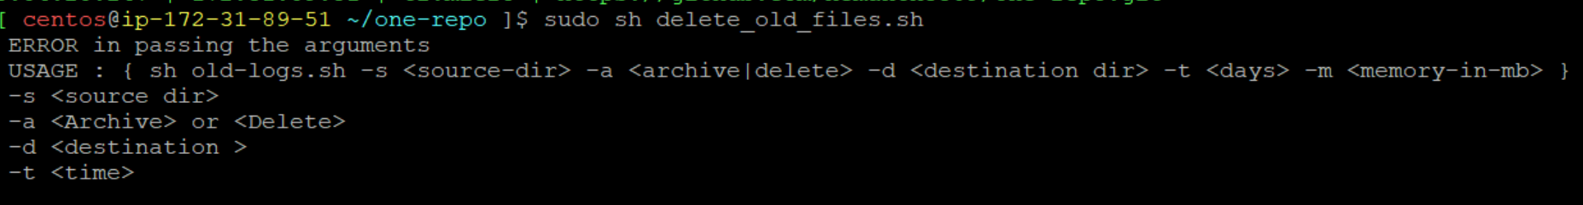

Case 2: When source directory doesn’t exists , displays as the source directory doesn’t exists



Case 3: Correct source directory and destination directory is provided but with no time



Case 4: Source, destination and time is provided to archive the files



But with the given range there are no files to archive, hence changing the time and re run the script

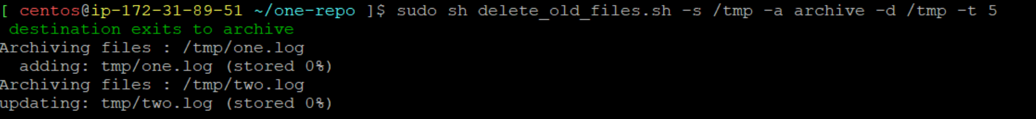

After Archiving the files

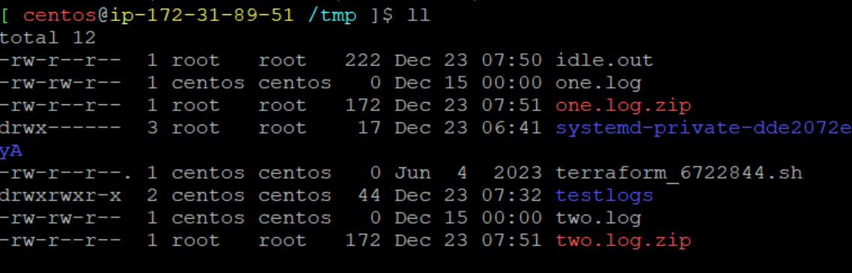

Case 5: Source exists but destination doesn’t exists.



Checks if the destination directory exists or not and displays the error to the user as above.

Case 6: To delete the files. Before delete the files 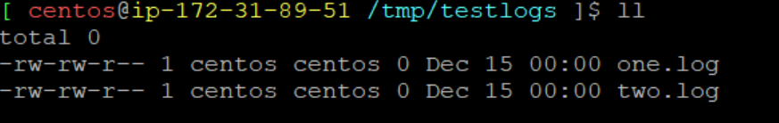

After deleting the files. And trying to re-run the script since there are no files to delete it displays as below.

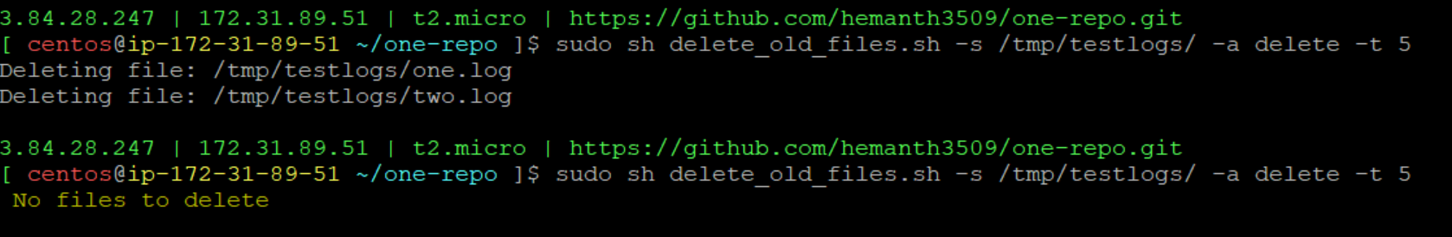

Case 7: Instead of providing number for the time filed, it will throw the below error.

